**ASSIGNMENT**

**(Bootstrap Basic and Advanced)**

# 1) What are the advantages of Bootstrap?

Ans: The advantages of Bootstrap are:-

Responsiveness, Browser compatibility, Customizable, JavaScript plugins, Consistency, Great grid system, Responsive design with Bootstrap, Design, Easy initiation ,Community support, Components, Easy to use, JavaScript, Mobile First, Open source, Responsive web design, Support, Documentation, Fast Development, Integration, it focuses on the user, large community

# 2) What is a Bootstrap container and how does it work?

Ans: Bootstrap Containers are the most basic layout element in Bootstrap. Bootstrap Containers are very essential and basic building blocks of bootstrap that wrap a page’s content. It’s responsible for setting and aligning content within it according to viewport or given device. Containers are defined within the container class (.container). In other words, we can say that containers are established the width for the layout to give the content. Elements and content are added within the container. Bootstrap has the default class or predefined class is “.container” & “.container-fluid” class for layout. Containers are used to contain, pad, and (sometimes) center the content within them.

Basically, there are three types of container classes available in bootstrap:

* Default-Container(container)
* Responsive-Container(along with sm, md, lg, xl, xxl)
* Fluid-Container(container-fluid)

# 3) What are the default Bootstrap text settings?

Ans: Bootstrap 5 uses a default font-size of 1rem (16px) and line height of 1.5 by default.

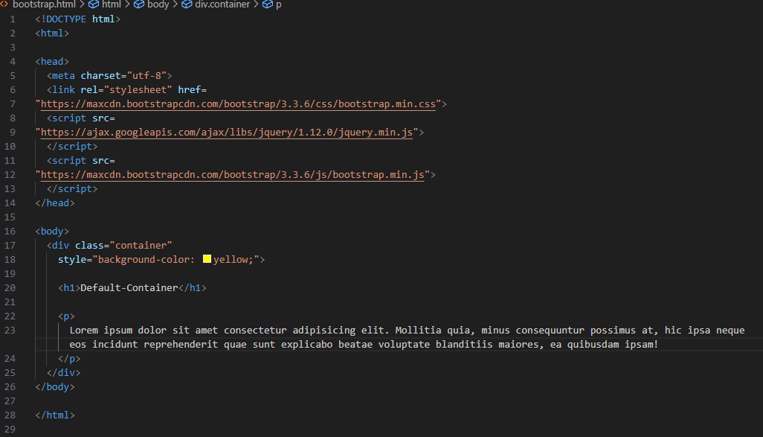

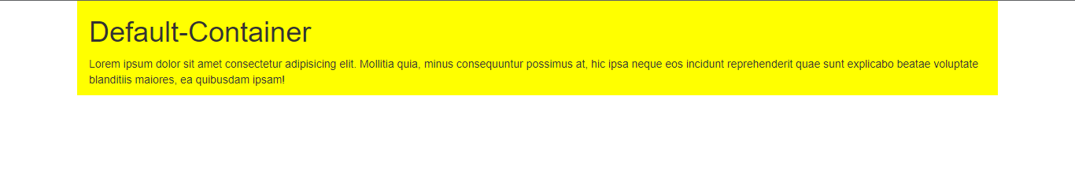

# 4) What do you know about the Bootstrap grid system?

Ans: Bootstrap’s grid system uses a series of containers, rows, and columns to layout and align content. It’s built with flexbox and is fully responsive.

The Bootstrap grid system has four classes:

xs (for phones - screens less than 768px wide)

sm (for tablets - screens equal to or greater than 768px wide)

md (for small laptops - screens equal to or greater than 992px wide)

lg (for laptops and desktops - screens equal to or greater than 1200px wide)

The example and syntax are shown below :-

<div class="row">

<div class="col-sm-4">.col-sm-4</div>

<div class="col-sm-4">.col-sm-4</div>

<div class="col-sm-4">.col-sm-4</div>

</div>

# 5) What is the difference between Bootstrap 4 and Bootstrap 5?

Ans:

|  |  |  |
| --- | --- | --- |
| **Features** | **Bootstrap 4** | **Bootstrap 5** |
| **Released date** | Bootstrap 4 was released in January 2018, and it marked a significant advance over previous versions. | Bootstrap 5 was released in May 2021. This version came after multiple iterations of alpha and beta releases, and as a result, it had a slew of important additions and new features. |
| **Links** | <link rel = "stylesheet" href = "https://cdn.jsdelivr.net/npm/bootstrap@4.6.1/dist/css/bootstrap.min.css">  <script src = "https://cdn.jsdelivr.net/npm/bootstrap@4.6.1/dist/js/bootstrap.bundle.min.js"> </script> | <link href = "https://cdn.jsdelivr.net/npm/bootstrap@5.1.3/dist/css/bootstrap.min.css" rel = "stylesheet">  <script src = "https://cdn.jsdelivr.net/npm/bootstrap@5.1.3/dist/js/bootstrap.bundle.min.js"> </script> |
| **Grid System** | Bootstrap 4 has five levels: xs, sm, md, lg, and xl. | Bootstrap 5 has six levels: xs, sm, md, lg, xl, and xxl. |
| **jQuery plug-in** | Bootstrap 4 includes jquery and all associated plug-ins. | Jquery has been deleted and replaced with vanilla JS and several functional plug-ins in Bootstrap 5. |
| **Color** | Bootstrap 4 provides a few colors for a web page. | Extra colors insert into the looks, and the card's color palette was upgraded. There are a variety of colors to pick from the Bootstrap 5 framework. |
| **Internet Explorer** | Bootstrap 4 is compatible with both Internet Explorer 10 and 11. | Bootstrap 5 does not support Internet Explorer 10 and 11. |
| **Elements of Forms** | Radio buttons and checkboxes appear differently in different operating systems and browsers. The form takes advantage of whatever basic browser features are available. | The appearance of form elements will not change while using a different operating system or browser. The forms alternate and add form controls; they are not browser-dependent. |
| **API for utilities** | We are unable to alter utilities in Bootstrap 4. | Bootstrap 5 provided us the ability to tweak and develop our utility. |
| **Utilize a gutter** | Bootstrap 4 uses glutter in a px font size. | Use .g* with font size set to rem in bootstrap 5. |
| **Vertical groups** | Columns can be positioned relative to one another. | Columns cannot be positioned relative to one another. |
| **Icons for Bootstrap** | Bootstrap 4 lacks SVG icons; we must rely on font-awesome for icons. | Bootstrap 5 has its own set of SVG icons. |
| **Jumbotron** | Bootstrap 4 compatible with jumbotron. | It is not compatible with jumbotron. |
| **Deck of cards** | The card deck is used to make an inset of cards with the same width and height. | The card deck class has been removed from bootstrap. |
| **Navbar** | We have the inline-block attribute, and the white dropdown will be the default for the dropdown-menu-dark class. | The inline-block property has been removed, and the dropdown-menu-dark class now has a black dropdown as the default. |
| **Generator of static websites** | Bootstrap 4 makes use of the Jekyll software. | Bootstrap 5 uses a fast static generator which is Hugo. |
| **Grid flexbox** | It makes vertical designs easier to construct, and columns and rows can be simply implemented. The justify-centre-content classes use directly to align according to the requirement. | A more complex grid system is offered, and columns do not have relative locations. |
| **CSS Usability** | Bootstrap 4 uses fewer CSS properties. | Bootstrap 4 uses more CSS properties. |
| **Off canvas component** | There is no off-canvas element. | The off-canvas component is now available. |

# 6) What is a button group, and what is the class for basic button group?

Ans: “Button Groups” in Bootstrap is a class of name “btn-group” which is used to create a series of buttons in groups (without spaces) vertically or horizontally.

Syntax: This is the basic syntax of the button group class where each button has its own class of “btn”.

<div class="btn-group">

<button type="button" class="btn">Click</button>

</div>

Buttons have a default border-radius on the first and last buttons of the group.

# 7) How can you use Bootstrap to make thumbnails?

Ans: To create thumbnails using Bootstrap :-

* Add an <a> tag with the class of .thumbnail around an image.
* This adds four pixels of padding and a grey border.
* On hover, an animated glow outlines the image.

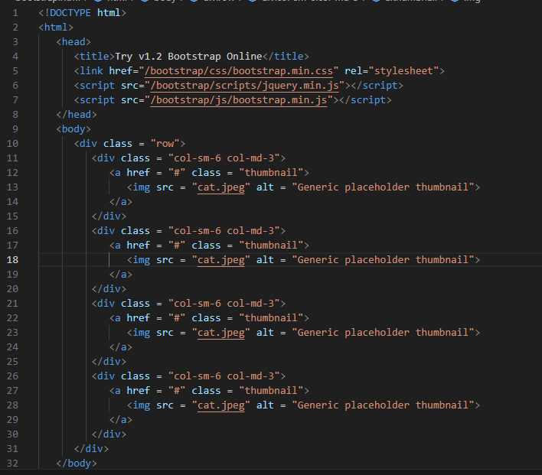



# 8) In Bootstrap 4 what is flexbox?

Ans: In Bootstrap 4, flex box is used to control the layout and alignment specification of Bootstrap 4 components. This box makes it easier to design flexible responsive layout structures without using float or positioning attributes.

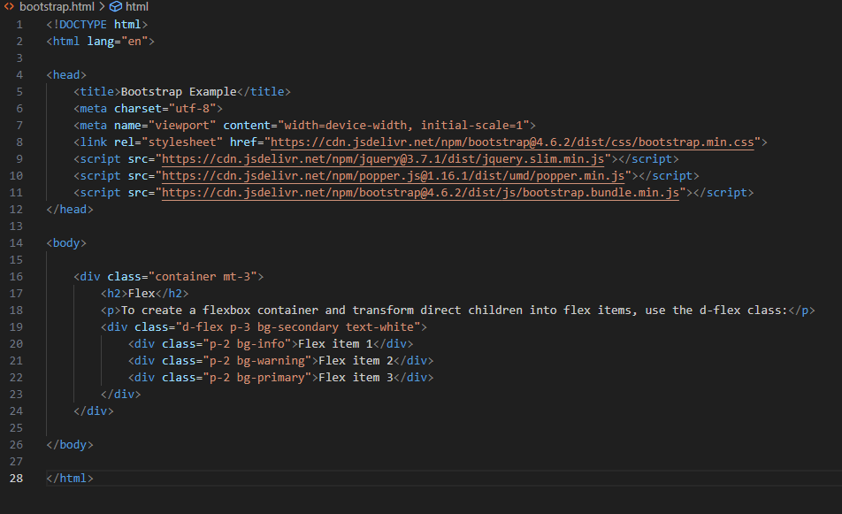



# 9) How can one create an alert in Bootstrap?

Ans: Alerts are created with the .alert class, followed by one of the four contextual classes .alert-success, .alert-info, .alert-warning or .alert-danger:

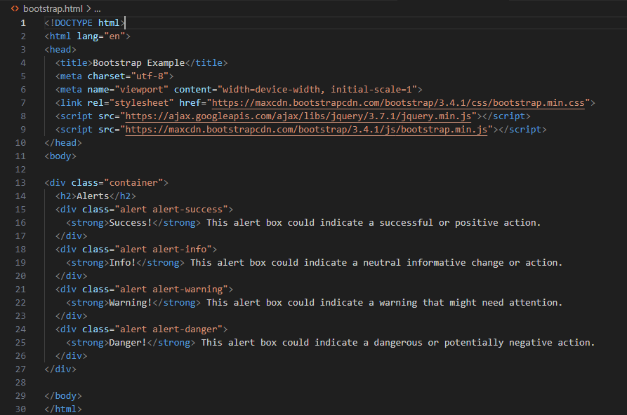

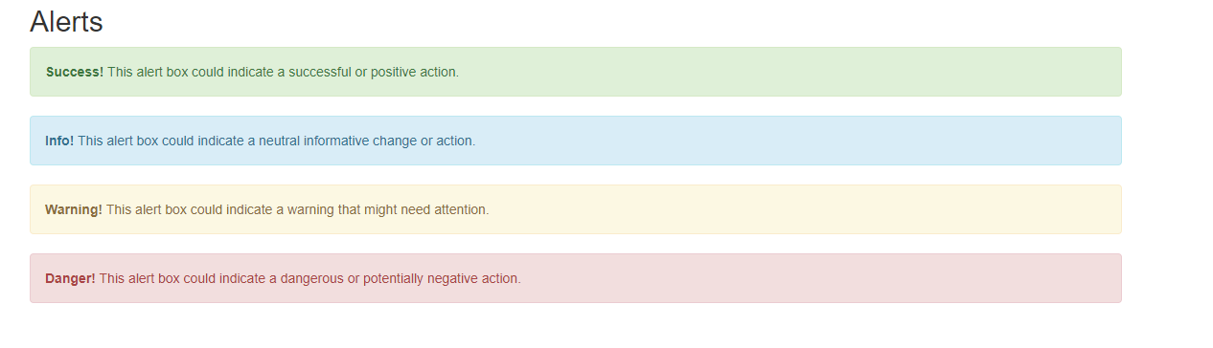,

# 10) What is a Bootstrap card and how can you create one?

Ans: A basic Bootstrap card consists of a .card class with the .card-body class, allowing you to add text, images, links, and other Bootstrap elements within a rounded border.

